**Q2. Loop to print factorial of a given number.**

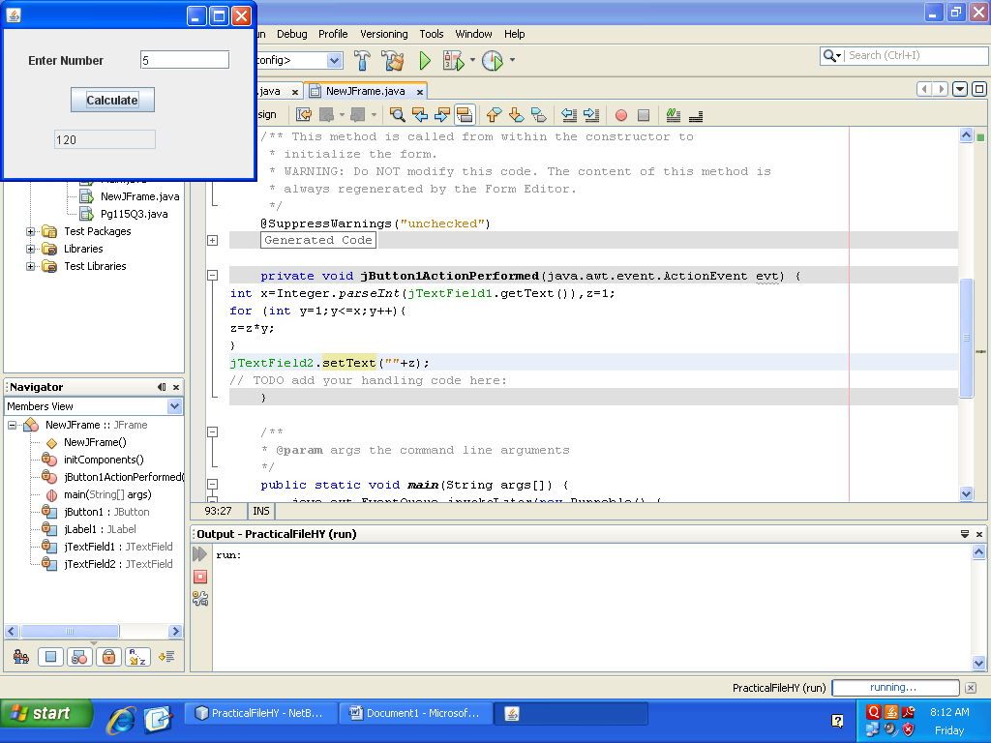

**Ans.** private void jButton1ActionPerformed(java.awt.event.ActionEvent evt) {

int x=Integer.parseInt(jTextField1.getText()),z=1;

for (int y=1;y<=x;y++){

z=z*y;

}

jTextField2.setText(""+z);

}

**Q4. Loop to print the sum of the series:**

**1 + ¼ + 1/7 + 1/10 + 1/13 + 1/16 + 1/19 + 1/22 + 1/25**

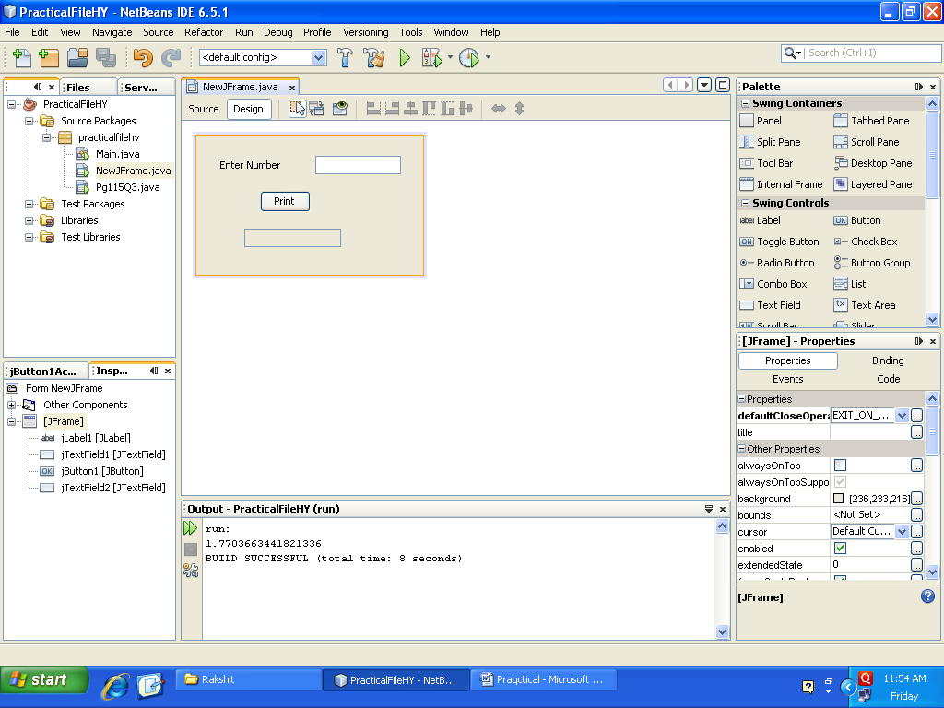

**Ans.** private void jButton1ActionPerformed(java.awt.event.ActionEvent evt) {

double x,y=0;

for (x=1;x<=25;x+=3)

y=y+(1/x);

System.out.println(""+y);

}

**Q6. Write code to translate to its equivalent name of the day of the week(e.g. 1 to Sunday, 2 to Monday…….7 to Saturday).**

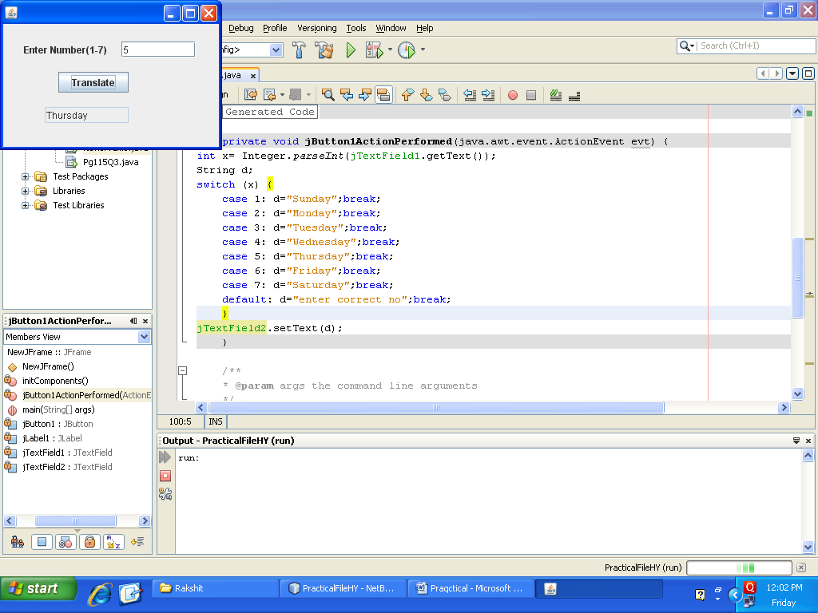

**Ans.** private void jButton1ActionPerformed(java.awt.event.ActionEvent evt) {

int x= Integer.parseInt(jTextField1.getText());

String d;

switch (x) {

case 1: d="Sunday";break;

case 2: d="Monday";break;

case 3: d="Tuesday";break;

case 4: d="Wednesday";break;

case 5: d="Thursday";break;

case 6: d="Friday";break;

case 7: d="Saturday";break;

default: d="enter correct no";break;

}

jTextField2.setText(d);

}

**Q8.Loop to display the following terms upto 10.**



**Ans.**

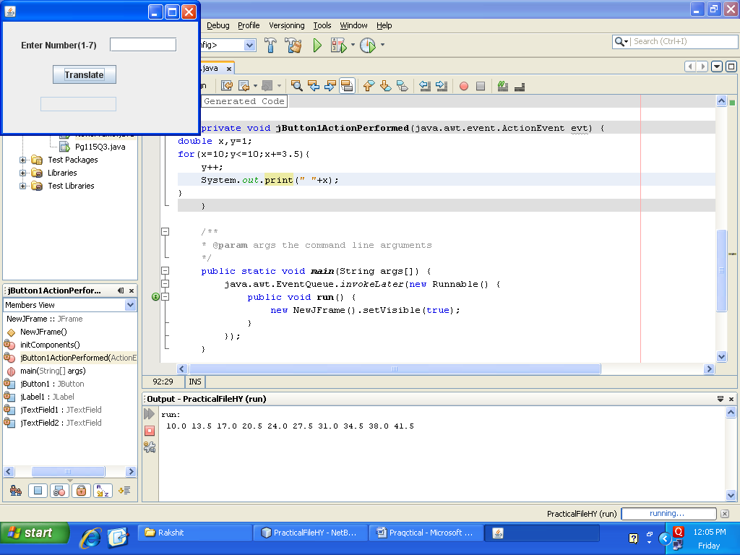

private void jButton1ActionPerformed(java.awt.event.ActionEvent evt) {

double x,y=1;

for(x=10;y<=10;x+=3.5){

y++;

System.out.print(" "+x);

}

}

**Q10. Given 3 numbers A, B and C, write code in java to write their values in decreasing order.**

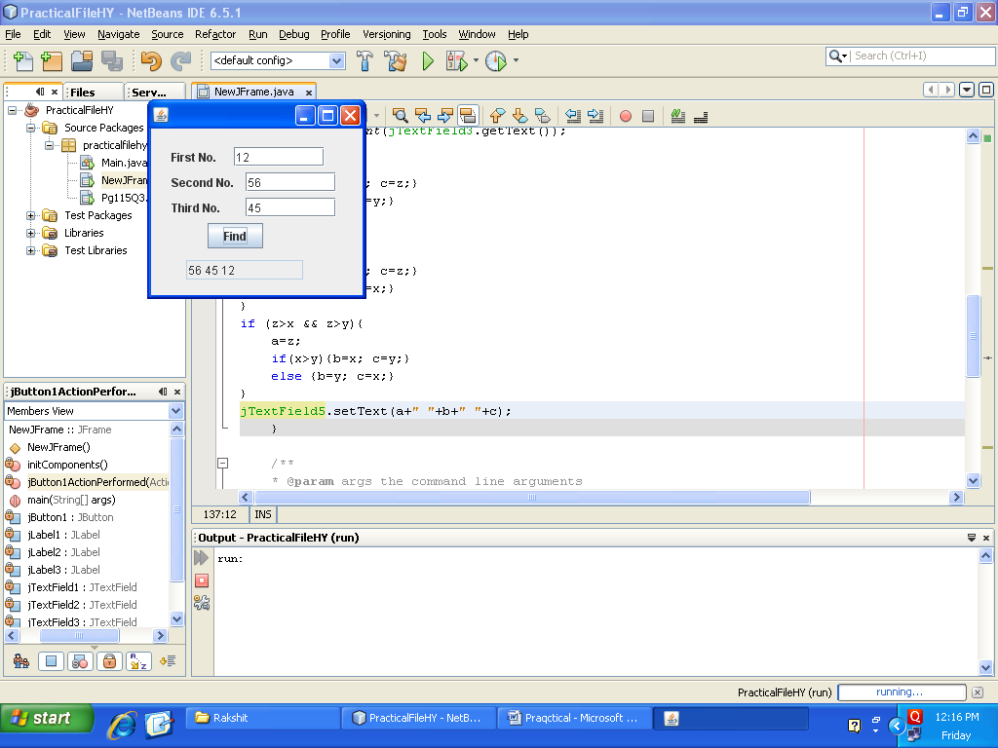

**Ans.** private void jButton1ActionPerformed(java.awt.event.ActionEvent evt) {

int x,y,z,a=0,b=0,c=0;

x=Integer.parseInt(jTextField1.getText());

y=Integer.parseInt(jTextField2.getText());

z=Integer.parseInt(jTextField3.getText());

if (x>y && x>z){

a=x;

If (y>z){b=y; c=z;}

else {b=z; c=y;}

}

if (y>x && y>z){

a=y;

if (x>z){b=x; c=z;}

else {b=z; c=x;}

}

if (z>x && z>y){

a=z;

if(x>y){b=x; c=y;}

else {b=y; c=x;}

}

jTextField4.setText(a+" "+b+" "+c);

}

**Q12. Given aGUI application having a layout as below:**

**`**

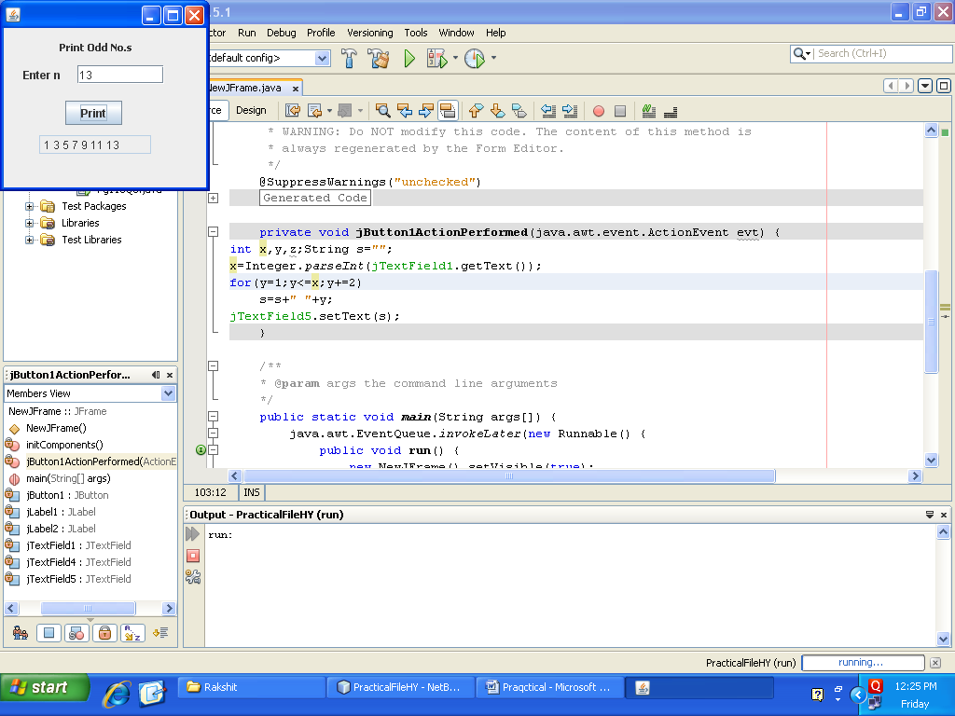

**Ans.** private void jButton1ActionPerformed(java.awt.event.ActionEvent evt) {

int x,y,z;String s="";

x=Integer.parseInt(jTextField1.getText());

for(y=1;y<=x;y+=2)

s=s+" "+y;

jTextField5.setText(s);

}